

MECHATRONIC SYSTEM INTEGRATION
(MCTA 3203)

SEMESTER 1, 2025/2026

MINI PROJECT :

Multi-Tier Smart Aid Glove and Belt Suite: An Integrated Safety and Mobility System for the Visually Impaired

SECTION 2

GROUP 12

NAME | METRIC NO.
AHMAD FARHAN BIN AHMAD NAHRUDI | 2317373
MUHAMMAD AIMAN BIN SAFAWI | 2318249
MOHD NAFIZ ZUHAIREE BIN MOHD NEEZAR | 2317423

DATE OF SUBMISSION :
21/1/2026
TITLE

Multi-Tier Smart Aid Glove and Belt Suite: An Integrated Safety and Mobility System for the Visually Impaired

AUTHORS

[Mohd Nafiz Zuhairee], [Muhammad Aiman Safawi], [Ahmad Farhan],
Department of Mechatronics Engineering, [International Islamic University Malaysia(IIUM)] Email: [nafizzuhairee11@gmail.com]

ABSTRACT
As global populations age and urban environments become increasingly complex, the need for intuitive, non-invasive assistive technologies for the visually impaired has never been more critical. This project presents a decentralized, wearable "Smart Aid Suite" designed to provide spatial awareness, thermal protection, and secure user identification through a multi-microcontroller architecture. Unlike traditional smart canes that offer limited feedback, our system utilizes a dual-node configuration consisting of an ESP32-based "Smart Glove" and an Arduino-based "Haptic Belt" connected via a dedicated Bluetooth Master-Slave link.
The system’s first layer of protection is identity-based; an integrated HuskyLens AI vision sensor serves as a security gateway, ensuring the device only activates its full suite of features upon recognizing the authorized user (Face ID1). Once verified, the ESP32 Glove monitors environmental hazards using a GY-906 non-contact infrared thermometer. By utilizing a three-stage threshold system adjusted via a potentiometer, the glove provides early-warning vibration patterns to alert the user of dangerous heat sources such as stoves or engines before physical contact occurs.
Simultaneously, the Arduino-based Belt functions as a navigation co-pilot. A TF-Luna LiDAR sensor, mounted on a 180-degree sweeping servo motor, continuously maps the path ahead. To provide directional intuition, the system translates spatial data into haptic feedback: obstacles detected on the left flank (0°-90°) trigger a left-side vibration motor, while right-side obstacles (91°-180°) trigger the right-side motor. This allows the user to "feel" the shape of their surroundings and navigate around obstacles without visual input.
Experimental results demonstrate that the integration of localized heat sensing and sweeping LiDAR distance mapping significantly reduces the cognitive load on the user compared to manual cane navigation. By separating the sensing and feedback units, the device ensures ergonomic comfort while maintaining high-speed data processing and wireless communication. This project successfully bridges the gap between affordable mechatronic components and sophisticated assistive AI, offering a scalable solution for enhancing the independence and safety of the visually impaired and elderly.

1. INTRODUCTION
Independence is one of the most significant challenges faced by the visually impaired and the elderly. While the traditional white cane has been the standard mobility aid for centuries, it is fundamentally limited: it can only detect obstacles through physical contact and is largely blind to hazards above the waist or environmental dangers like extreme heat. As our world becomes more fast-paced and technologically dense, there is an urgent need for an "intelligent" layer of protection that goes beyond physical touch.
Our project, the Multi-Tier Smart Aid Glove and Belt Suite, was born from the idea that a mobility aid should not just be a tool, but a sensory extension of the user. By combining the processing power of the ESP32 and the versatility of the Arduino Uno, we have developed a wearable ecosystem that splits the tasks of "sensing" and "acting" between a smart glove and a haptic belt. This decentralized approach ensures that the user is not overwhelmed by a single device, but rather guided by a coordinated system of feedback.
The innovation of this device lies in its three-pillar safety architecture:
- Identity-Based Activation: Safety begins with security. By integrating the HuskyLens AI vision sensor, we ensure that the device remains in a standby state until it recognizes the specific user (Face ID1). This prevents unauthorized use and ensures that the system’s settings are tailored to a specific individual’s needs.
- Thermal Hazard Awareness: One of the most dangerous scenarios for a visually impaired person is a non-contact hazard, such as a hot stove, a boiling kettle, or an idling vehicle engine. Our system addresses this through the GY-906 infrared thermometer. By allowing the user to toggle between sensitivity modes via a potentiometer, the glove provides a "thermal shield" that alerts the user to heat before they ever touch the source.
- Dynamic Spatial Mapping: Traditional sensors often provide a simple "stop/go" signal. By mounting a TF-Luna LiDAR on a 180-degree sweeping servo, we provide a radar-like experience. The device doesn't just tell the user that something is there; it tells them where it is. By splitting haptic feedback between the left and right sides of the belt, the user develops a spatial intuition, allowing them to navigate complex hallways and avoid obstacles fluidly.
Ultimately, this project is more than just a collection of sensors and microcontrollers. It is a prototype for a future where technology restores a sense of autonomy to those who have lost it. By leveraging wireless Bluetooth communication and real-time AI processing, we aim to provide a low-cost, high-impact solution that makes the world a safer, more navigable place for the blind and the elderly.
The necessity of this decentralized "Glove-to-Belt" architecture is highlighted when comparing it to existing market solutions and academic prototypes. While many previous designs rely on a single, heavy handheld unit, our system prioritizes ergonomic comfort and "distributed intelligence" to prevent user fatigue. By offloading complex computer vision to the ESP32 Glove and real-time spatial scanning to the Arduino Belt, we achieve a higher level of responsiveness and safety coverage than traditional smart sticks.
To better understand the unique value of the Integrated Smart Aid Suite, it is essential to look at how it improves upon the limitations of earlier "Smart Cane" iterations. Previous projects often struggled with narrow sensor ranges, a lack of environmental hazard detection (like heat), or a reliance on external cloud services that can fail in low-connectivity areas.
The following table provides a comparison between our proposed Integrated Smart Aid Suite and various existing technologies developed for the visually impaired. This analysis justifies the selection of our specific hardware components such as LiDAR and AI vision over common ultrasonic or app-dependent systems.

Ref/Year | Project Title | Advantages | Disadvantages | Compared to My Proposed Project
Our Project | Integrated Smart Aid Suite (Glove & Belt) | Combines AI identity locking, 180° LiDAR scanning, and non-contact heat detection. | Requires two power sources; no GPS-based tracking. | Offers superior real-world safety by detecting thermal hazards and providing directional haptic feedback.
[1] 2018 | Ultrasonic Sensor Based Smart Blind Stick | Simple obstacle detection with buzzer; low cost | Short range (5–35 cm); lacks emergency and water alert | Our project has broader safety coverage including heat detection and directional scanning
[2] 2022 | SCBIoT: Smart Cane for Blinds using IoT | Combines GPS, obstacle detection, and LED light | Dependent on Wi-Fi hotspot; high battery consumption | Our project is a simpler, offline-capable system that focuses on immediate physical safety
[3] 2019 | Smart Electronic Stick for Visually Impaired | Uses IR camera, Google API, emergency system | 1m range only; heavily app-dependent | Our project is more hardware-reliable and does not rely on external APIs or smartphone apps
[4] 2018 | Smart Blind Stick Using Arduino | Voice feedback, wearable, sonar-based | App-reliant; no lighting or water detection | Our project covers more physical hazards (heat); ours offers tactile directional cues
[5] 2018 | Smart Blind Stick for Visually Impaired | Real-time tactile feedback using sonar sensors | Lacks audio, water, and emergency features | Our LiDAR system provides a wider 180° sweep compared to static sonar sensors
Table 1 : Table of comparison
As seen in the comparison above, most existing designs focus on "Contact-Based" or "Sonar-Based" detection, which often fails to recognize high-level environmental dangers. Our project bridges these gaps through three specific design choices:
- LiDAR vs. Sonar: While Sonar sensors (as seen in Ref [1] and [5]) are low-cost, they suffer from narrow detection angles and interference. Our use of TF-Luna LiDAR on a sweeping servo provides a high-resolution 180-degree map, allowing the user to distinguish between an obstacle on the left versus the right.
- Offline AI vs. API Reliance: Projects like Ref [3] rely on the Google API, making them useless without an internet connection. Our HuskyLens integration performs all AI face recognition locally on the glove, ensuring the device works anywhere.
- Thermal Protection: Unlike any of the comparative projects listed, our suite includes the GY-906 sensor to address the specific danger of non-contact heat hazards, such as stoves or car engines, providing a "thermal shield" that ultrasonic sticks lack.

2. METHODOLOGY
The development of the Multi-Tier Smart Aid Glove and Belt Suite follows a modular mechatronic design, prioritizing "Distributed Intelligence." This approach ensures that the processing load is shared between an ESP32 Master Node and an Arduino Slave Node, preventing system lag during critical safety events.

2.1 Material and Equipment
The following materials and equipment were utilized during the development of the Multi-Tier Smart Aid Glove and Belt Suite to ensure high-speed processing, precise environmental sensing and reliable wireless communication:
- ESP32 Microcontroller: Serves as the Master Node on the glove, selected for its dual-core processing capabilities and built-in Bluetooth/Wi-Fi modules.
- Arduino Uno R3: Serves as the Slave Node on the belt, utilized for its stable 5V logic and ease of integration with motor shields for mechanical control.
- HuskyLens (AI Vision Sensor): An easy-to-use AI machine vision sensor used for Face Recognition (Face ID1) to authorize system activation.
- TF-Luna LiDAR Module: A short-range Laser Radar used for high-frequency distance measurements (up to 8 meters) with millimeter precision.
- MLX90614 (GY-906) Infrared Thermometer: A non-contact thermal sensor used to detect the surface temperature of objects via infrared radiation.
- SG90 Micro Servo Motor: Actuates the 180-degree sweep of the LiDAR sensor to create a dynamic spatial map.
- L293D Motor Shield: Integrated with the Arduino to drive the high-current vibration motors for haptic feedback.
- ERM Vibration Motors (x2): Eccentric Rotating Mass motors used to provide tactile directional alerts to the user's waist.
- HC-05 Bluetooth Module: Facilitates the serial wireless communication link between the Arduino Belt and the ESP32 Glove.
- 10k Potentiometer: Used as an analog input for the user to manually cycle through three distinct thermal safety thresholds.

2.2 Project Development
The system architecture is divided into two wearable units connected via a wireless Bluetooth Serial (SPP) link.
- Glove Module (Sensing & Security): Controlled by the ESP32, this unit manages the high-complexity data from the HuskyLens AI Camera and the MLX90614 (GY-906) Thermal Sensor. It also features a potentiometer for user-adjustable sensitivity.
- Belt Module (Navigation & Feedback): Controlled by the Arduino Uno, this unit manages the mechanical sweep of the TF-Luna LiDAR and the dual-motor haptic feedback system.
The operational logic of the suite is designed around a "Safety-First" hierarchy. As shown in the flowchart below, the system remains in a standby mode until the HuskyLens confirms the user’s identity. Once authenticated, the system initiates a parallel loop of thermal monitoring and spatial scanning.
- Priority Interrupt: The heat-sensing logic on the ESP32 has the highest priority. If a "High Heat" condition is met, it sends an interrupt signal ('H') that overrides the LiDAR navigation to trigger an emergency vibration pattern.
This Priority Interrupt mechanism ensures safety is absolute. When heat exceeds the threshold, the ESP32 sends the 'H' command, triggering an immediate Hazard Override State on the belt:
- Mechanical Halt: The LiDAR servo stops its sweep instantly to focus the user’s attention.
- Synchronized Alarm: Both left and right vibration motors activate together, creating a powerful "Emergency Pulse" rhythm.
- Haptic Distinction: This dual-vibration pattern is physically different from the single-sided navigation pulses, signaling an intuitive "Stop" command.
The system only resumes navigation once the temperature returns to the "Safe Zone," ensuring that thermal protection always takes precedence over pathfinding.This hierarchical logic is designed to prevent "sensory overload" by ensuring only the most critical information reaches the user at any given time. Below is the Flowchart of the system, illustrating the logic transition from identity verification to the prioritized hazard sensing loop.

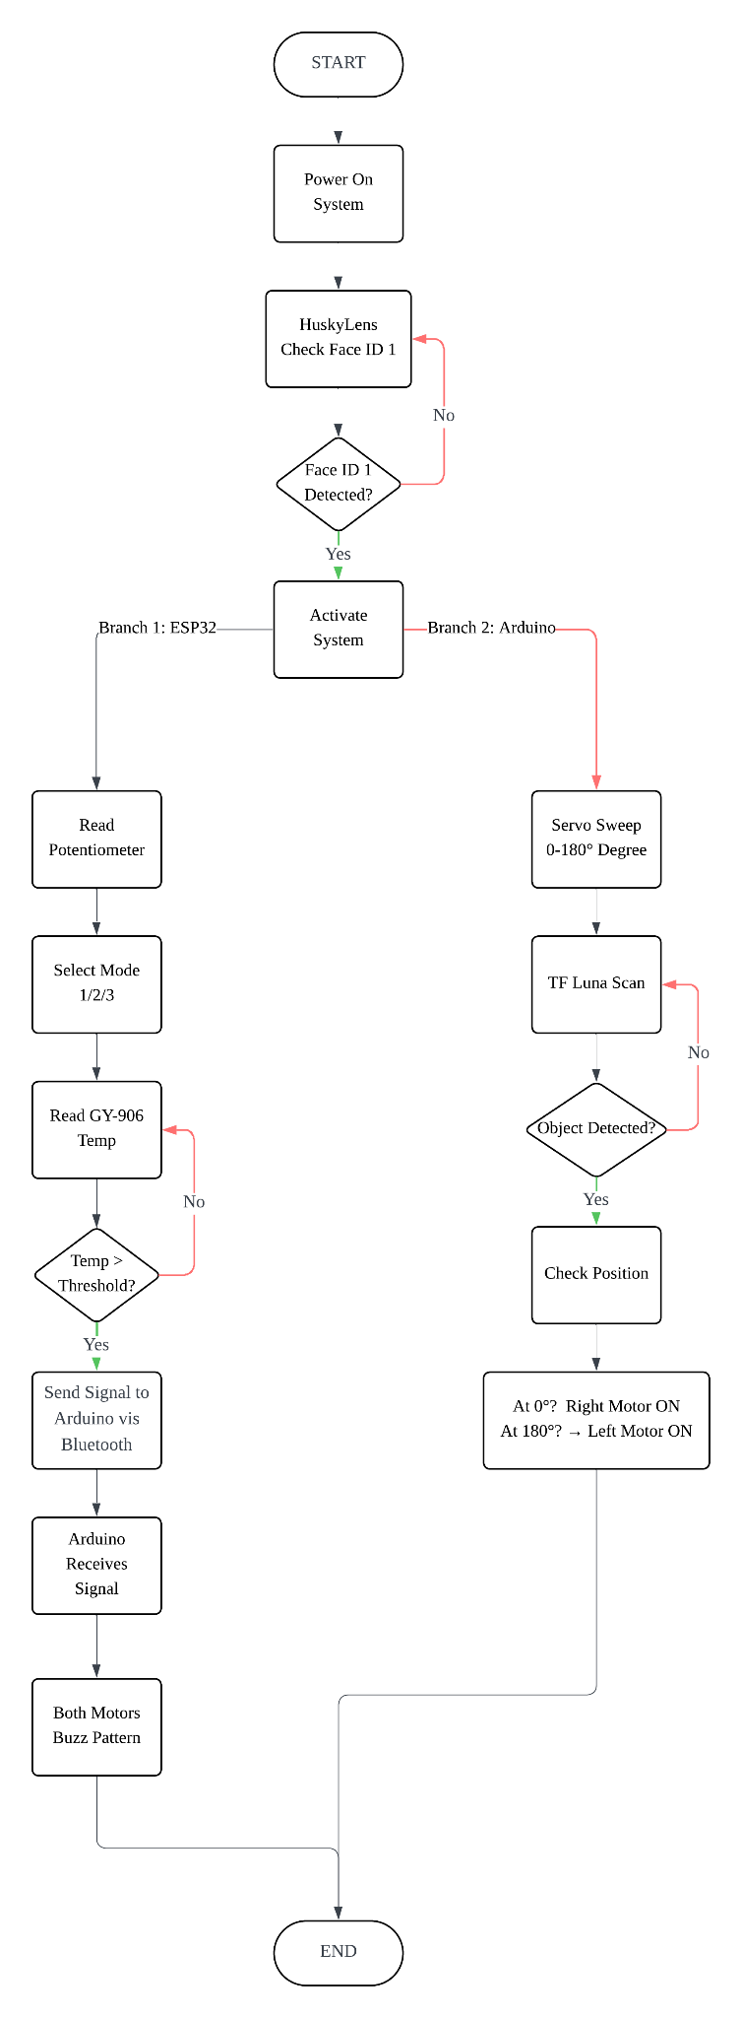

Figure 1 : Flowchart of The System

2.3 Schematic Diagram and Prototype Setup

2.3.1 Smart Belt Schematic Diagram
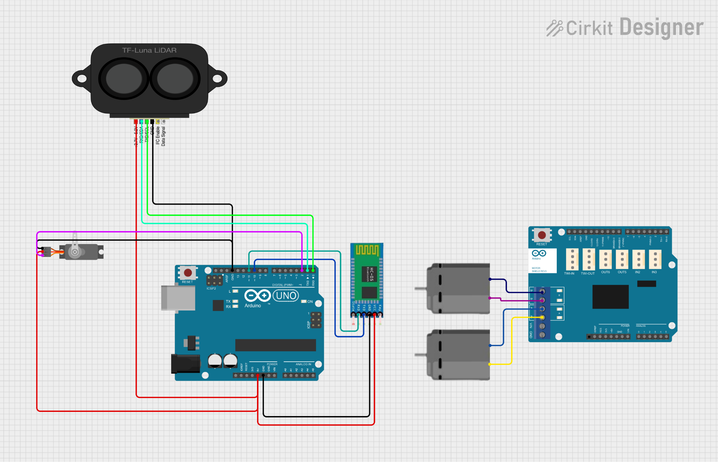

Figure 2 : Smart Belt Schematic Diagram

2.3.2 Smart Glove Schematic Diagram

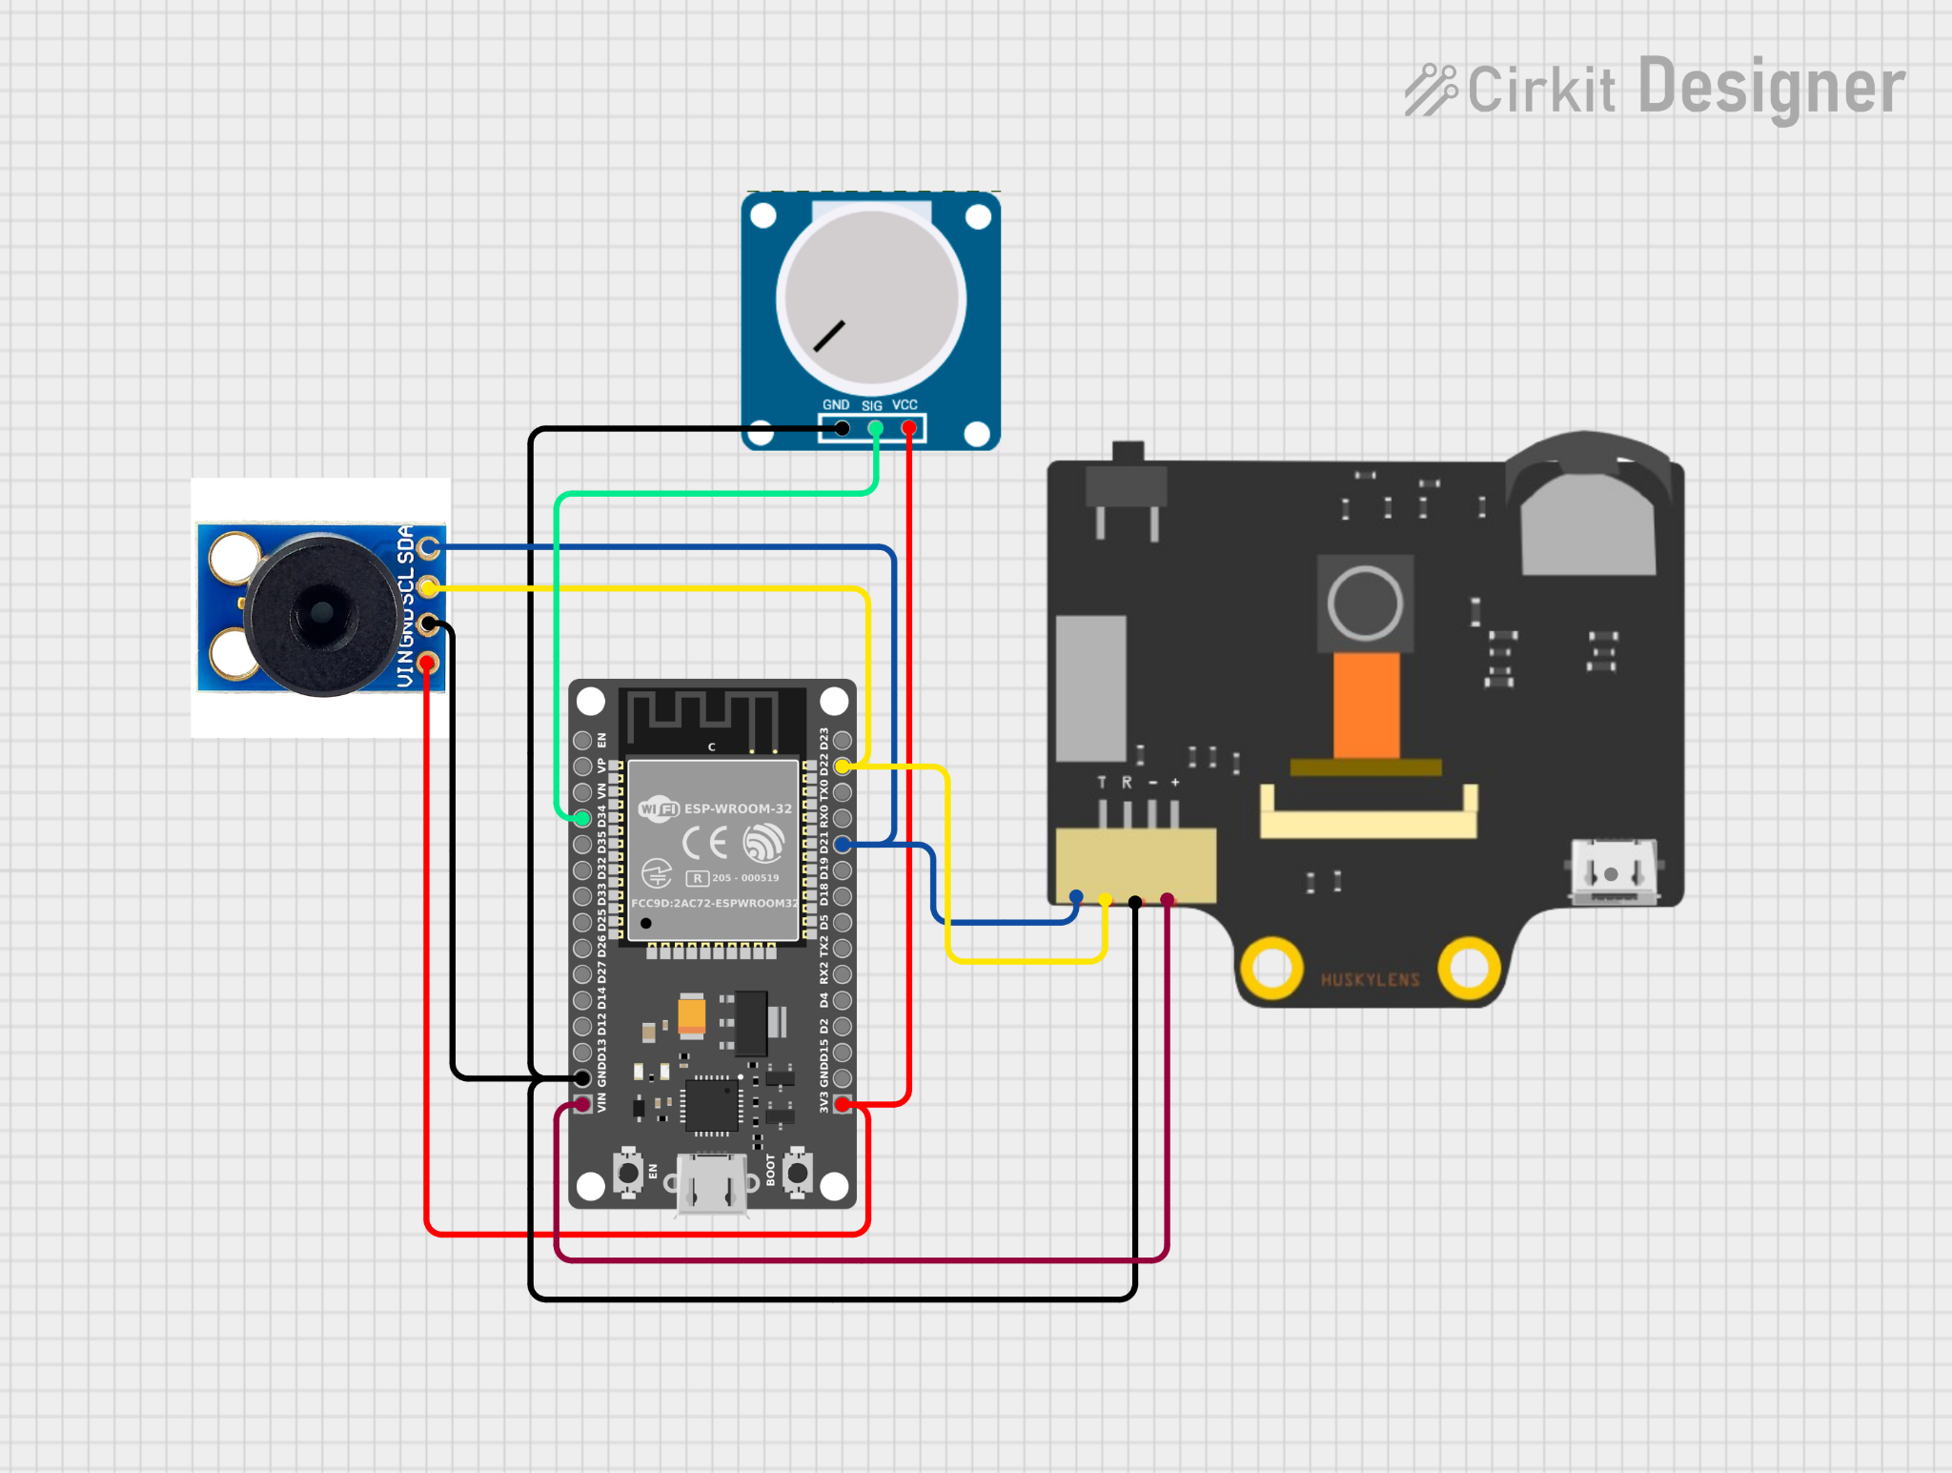
Figure 3 : Smart Glove Schematic Diagram

2.3.3 Conceptual Design Of Smart Glove And Belt
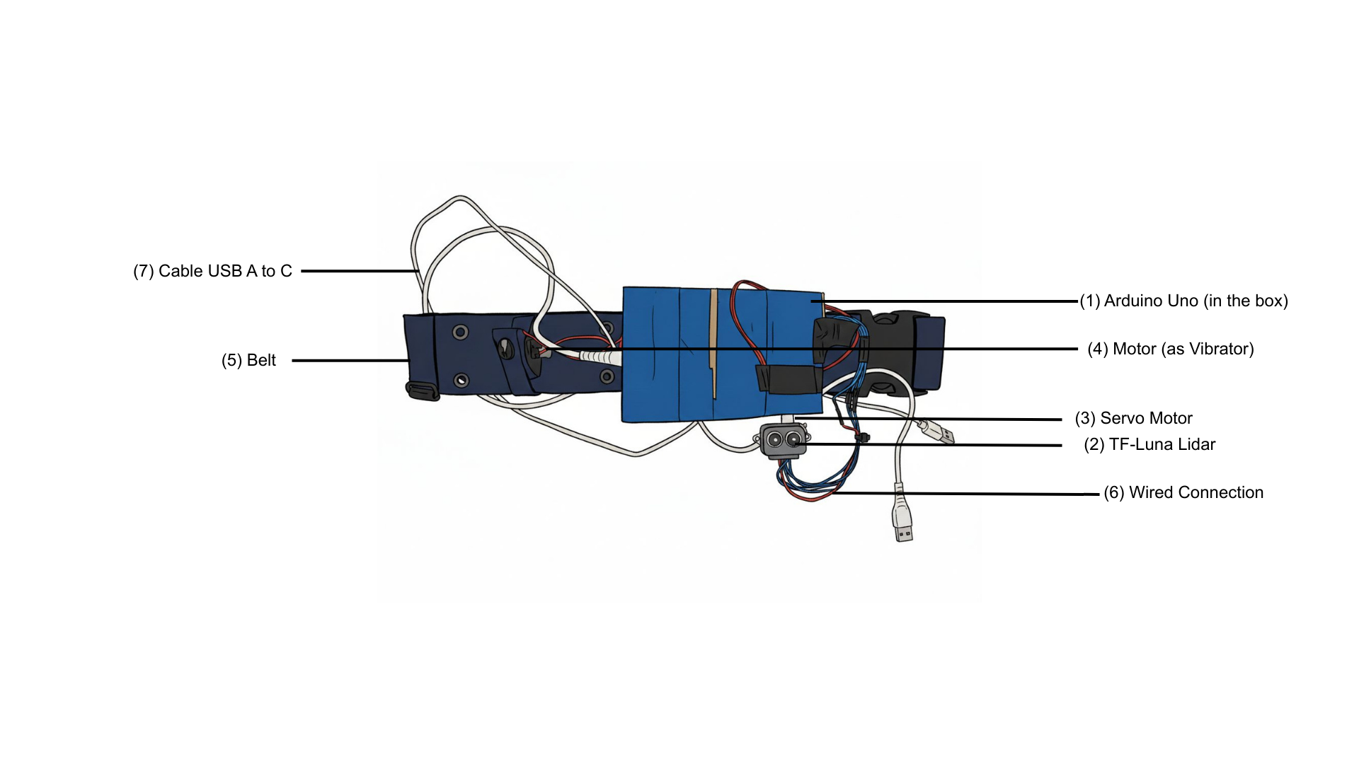

Figure 4 : Conceptual Design Of Smart Belt

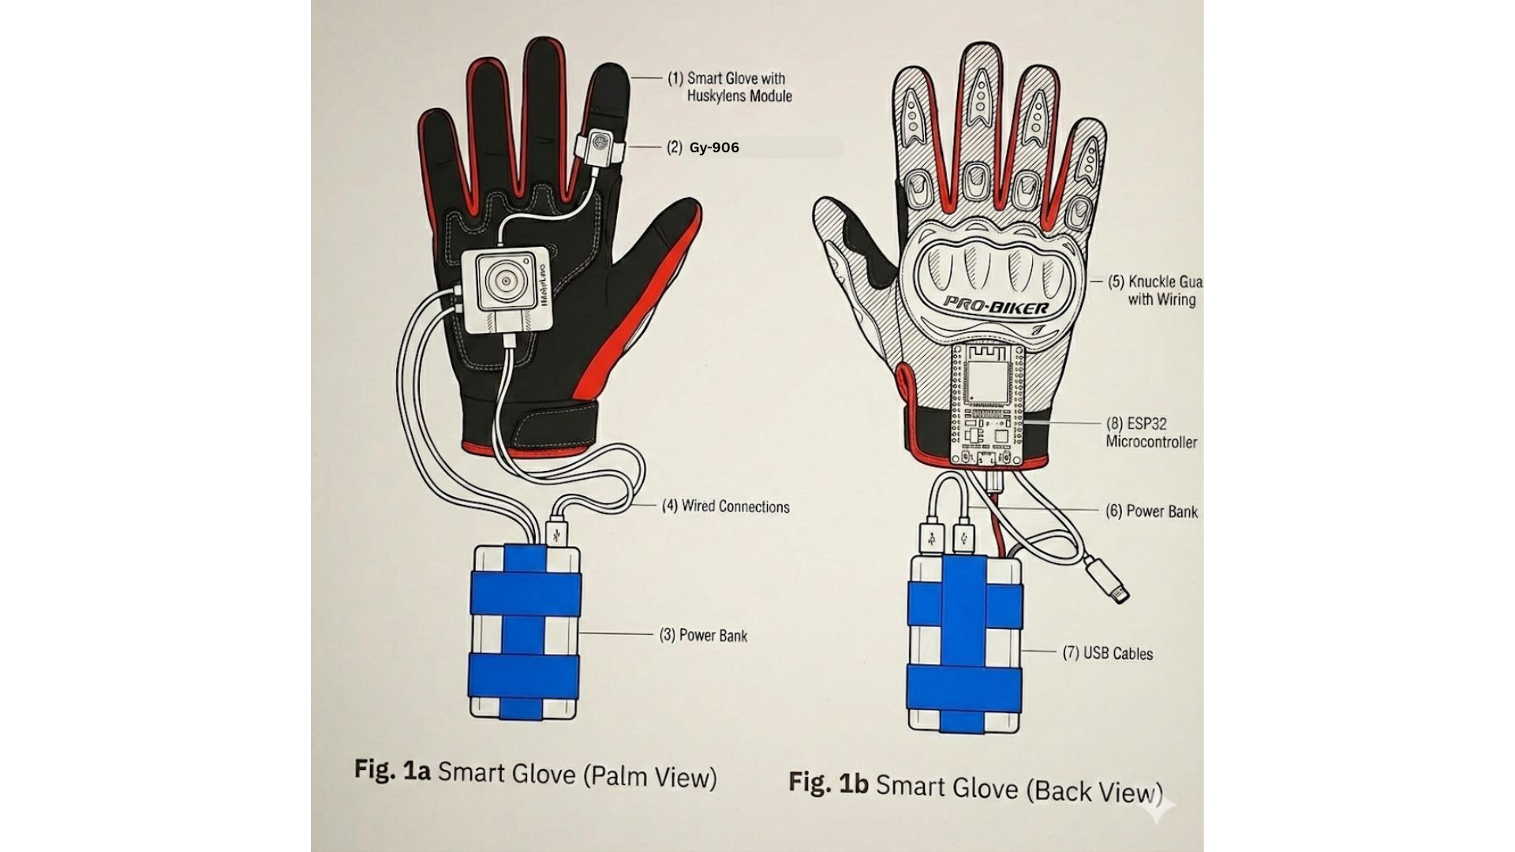

Figure 5 : Conceptual Design Of Smart Glove

2.3.4 Final Prototype Of Smart Glove And Belt
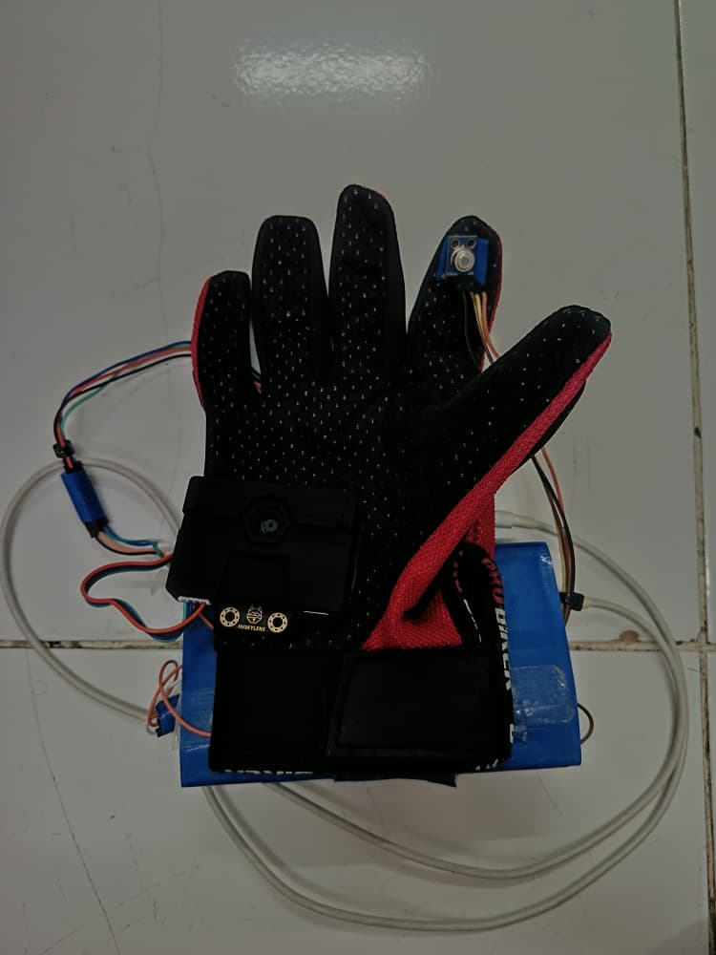
GY-906
HuskyLens

Figure 6 : Back View Of Smart Glove
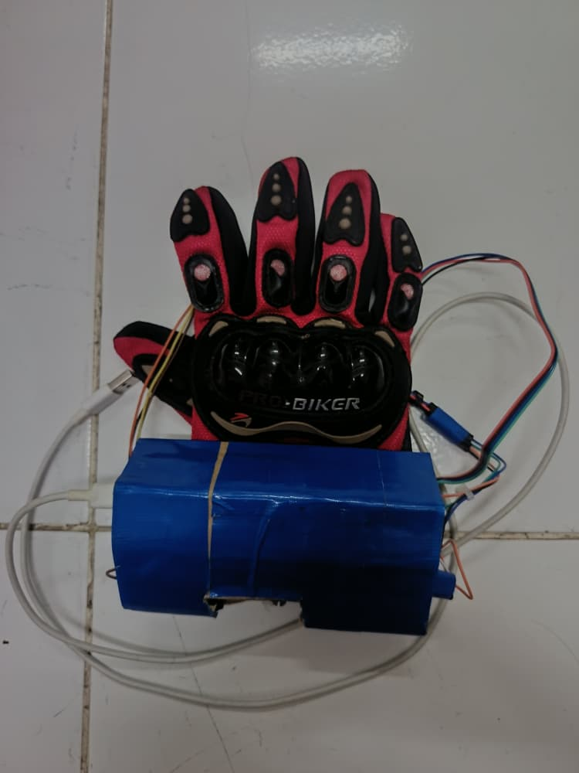
HC-05 bluetooth Module
Potentiometer
ESP32 Microcontroller
USB-A to USB-C cable

Figure 7 : Palm View Of Smart Glove

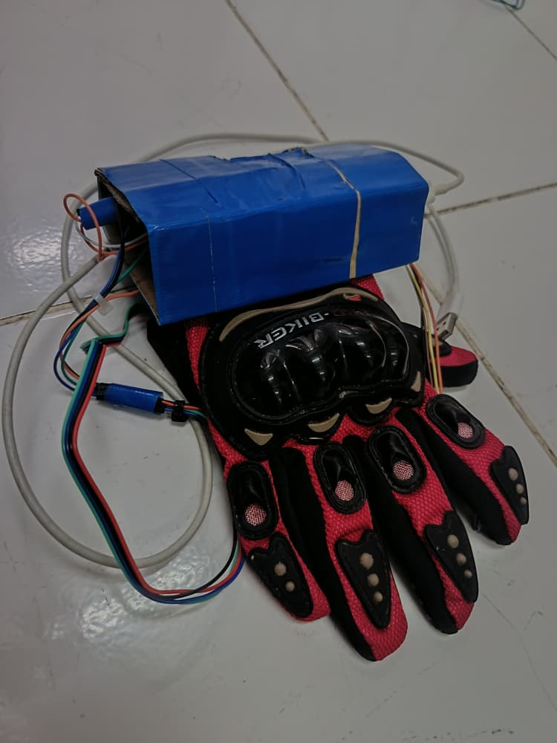

Figure 8 : Isometric View Of Smart Glove

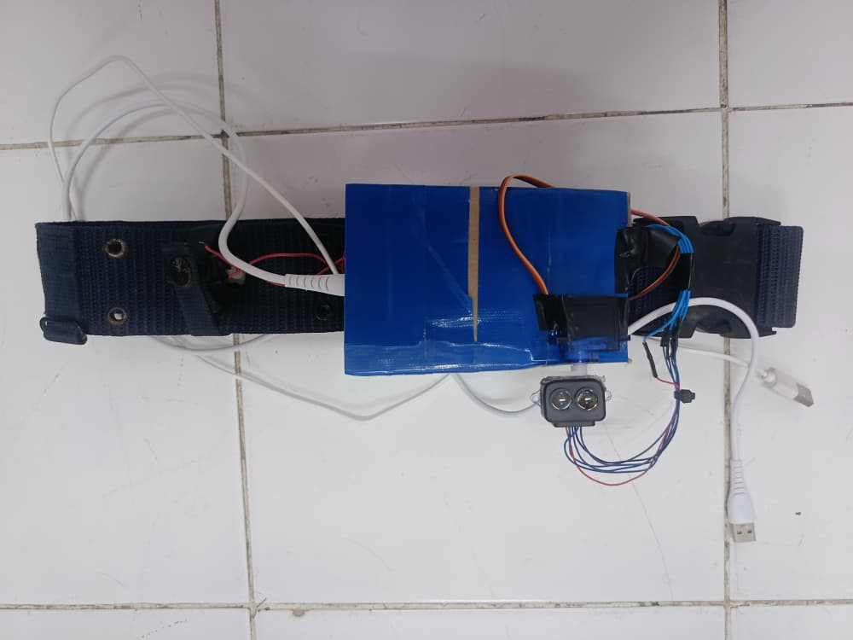
Arduino Uno Microcontroller
TF-Luna LiDAR Module
Servo Motor
Vibration Motos

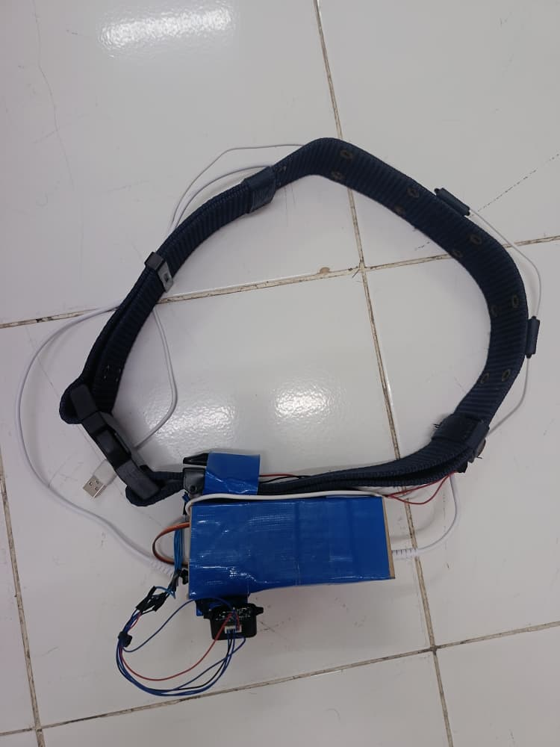
Figure 9 : Front View Of Smart Belt

Figure 10 : Top View Of Smart Belt

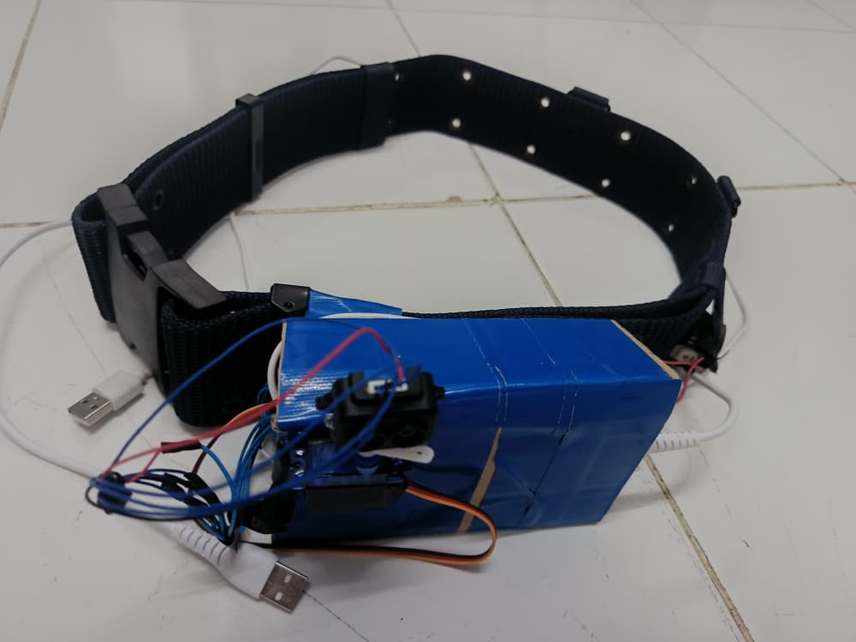

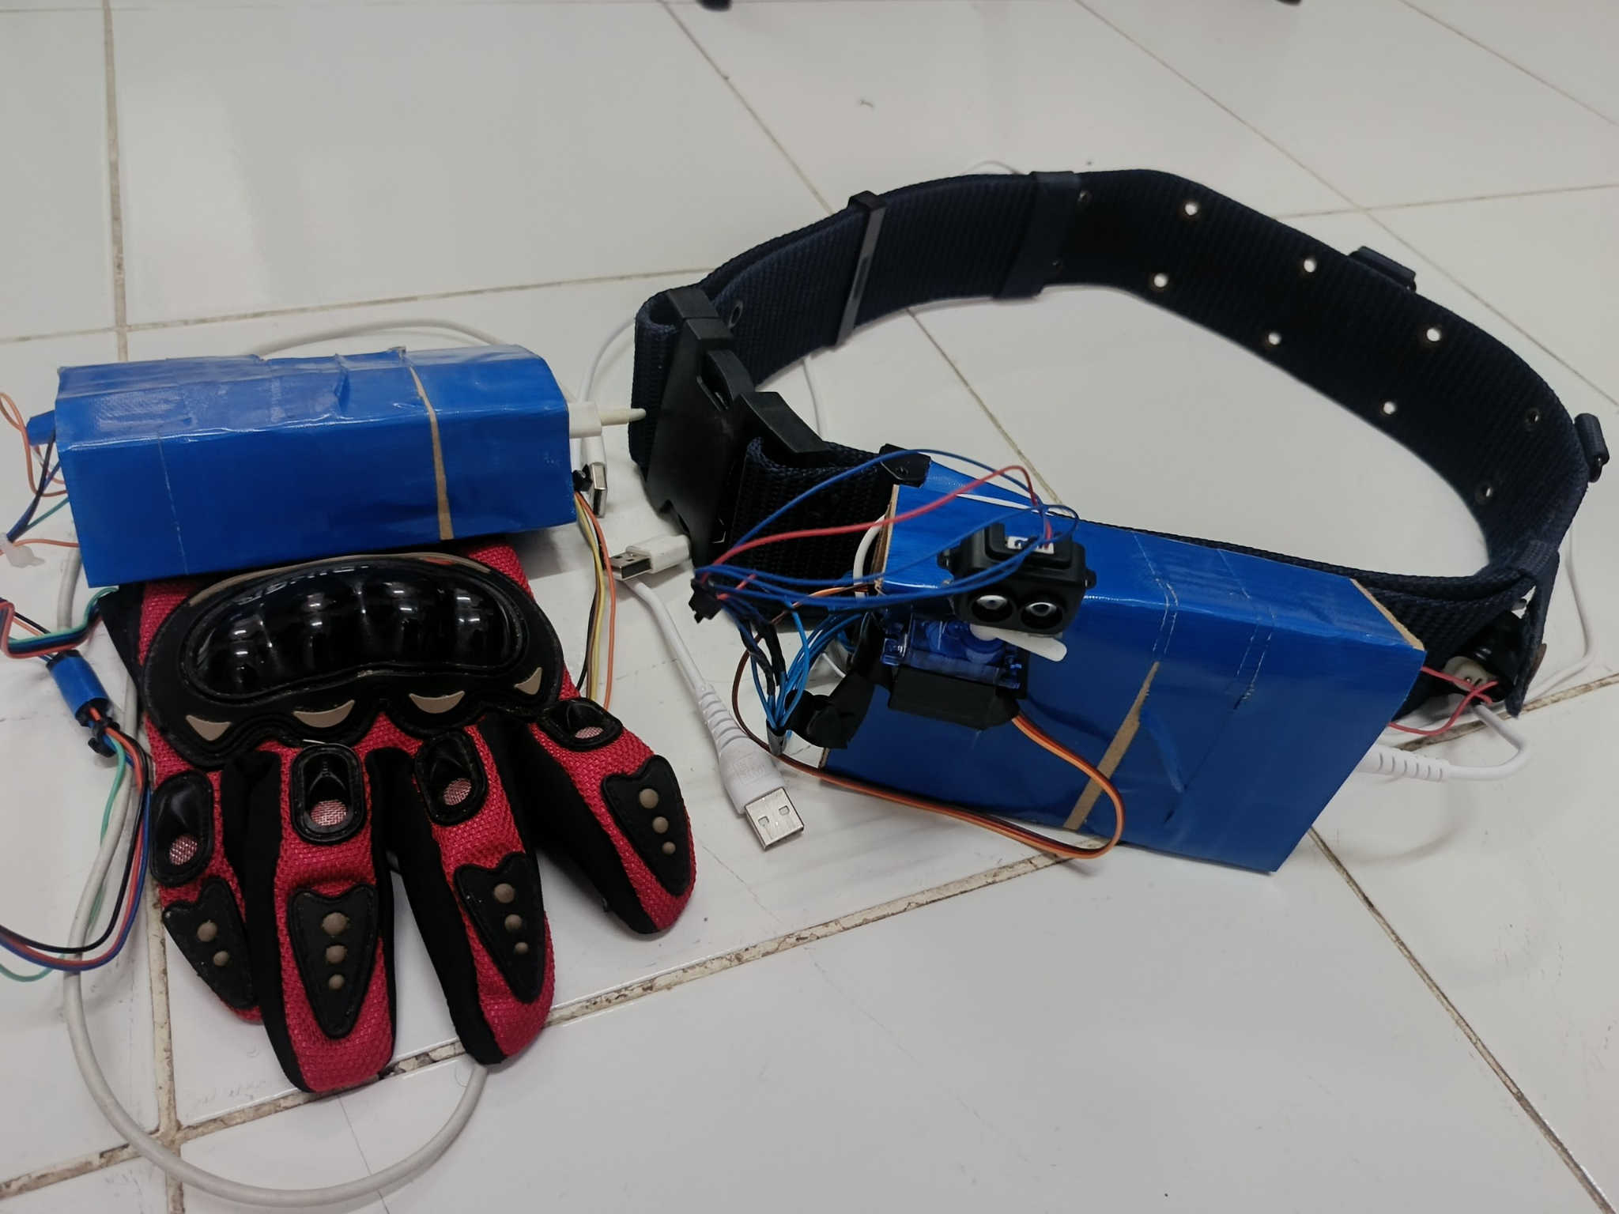
Figure 11 : Isometric View Of Smart Belt

Figure 12 : The Final Prototype Of Smart Glove And Belt

The image illustrates the final prototype of Smart Glove And Belt, consisting of the sensing glove and the haptic navigation belt. This final prototype demonstrates a functional decentralized architecture where the two units communicate wirelessly to provide a comprehensive safety ecosystem for the user.

Technical Description Of Components:

The Smart Glove (Sensing Node):

Designed as a wearable interface, the glove integrates the ESP32 microcontroller (housed within the blue protective enclosure) to handle high-level AI and thermal processing.

The placement allows the user to naturally point the palm or the back of the hand toward objects to trigger the HuskyLens (identity verification) and the GY-906 sensor (thermal shield) without requiring physical contact.

The Haptic Belt (Navigation Node):

The belt serves as the central hub for spatial awareness, featuring a TF-Luna LiDAR sensor mounted on a high-torque micro-servo.

This "Radar Unit" is positioned to provide a 180-degree horizontal scan of the user's path, translating distance data into vibration pulses.

The heavy-duty buckle and adjustable strap ensure the belt remains stable during the mechanical sweep of the servo, providing consistent haptic feedback to the waist.

Power and Connectivity:

The prototype uses high-capacity power banks (blue units) for extended operation.

The Bluetooth Serial (SPP) link eliminates the need for physical wires between the hand and the waist, ensuring that the user’s range of motion is not restricted while walking or reaching for objects.

Summary Of Operation:

In this final configuration, the system achieves a "Safety-First" hierarchy. The glove monitors for specific threats (identity and heat), while the belt provides a constant "clear path" guide. This distributed design minimizes the weight on the user's hand while maximizing the sensory input provided to the body, resulting in an intuitive and robust assistive tool.

2.4 System Design and Technical Implementation

The development of the Integrated Smart Aid Suite follows a structured mechatronic approach, dividing the workload between two specialized microcontrollers to ensure real-time responsiveness and ergonomic wearability. The methodology is centered on creating a seamless wireless link between sensing (the glove) and navigation (the belt).

2.4.1 The Sensing Node: The ESP32 Smart Glove

The glove acts as the user's "digital hand," allowing them to interact with environmental hazards without physical contact. We chose the ESP32 as the brain of the glove due to its dual-core processing power, which is essential for handling AI vision and Bluetooth communication simultaneously without latency.

Security via AI Vision: We integrated a HuskyLens AI camera on the back of the hand. We programmed a "Safety Gate" logic: the system remains in a low-power "Standby" mode until the camera identifies the authorized user (Face ID1). This ensures that the high-power sensors only drain the battery when the device is actually being worn by its owner.

The Thermal Shield: To protect against "invisible" hazards like hot stoves or engines, we mounted a GY-906 (MLX90614) non-contact infrared sensor near the palm. Unlike traditional thermometers, this sensor reads the thermal radiation of an object from 10–20 cm away.

User Interface: We added a physical potentiometer on the wrist. This allows the user to manually adjust the "safety buffer" such as higher sensitivity for indoor cooking or lower sensitivity for outdoor walking on a hot sunny day.

2.4.2 The Navigation Node: The Arduino Haptic Belt

While the glove looks for specific hazards, the belt is responsible for constant spatial awareness. We used an Arduino Uno with a motor shield to handle the high-speed mechanical movements of the radar system.

180-Degree Radar Sweep: We mounted a TF-Luna LiDAR sensor on a micro-servo. The servo is programmed to "sweep" back and forth like a lighthouse, covering the full 180 degrees in front of the user. This is a massive upgrade over stationary ultrasonic sensors, which often have "blind spots."

Spatial Mapping Logic: The real challenge was translating distance data into something a blind person can "feel." We split the sweep into two zones:

The Left Zone (0°–85°): If the LiDAR sees an obstacle here, it pulses the Left Vibration Motor.

The Right Zone (95°–180°): If it sees an obstacle here, it pulses the Right Vibration Motor.

This allows the user to intuitively "walk away" from the vibration, navigating around obstacles fluidly.

2.4.3 Wireless Synergy and Hazard Priority

A major part of our methodology was perfecting the "Bluetooth Handshake." The ESP32 (Glove) is the Master, and the Arduino (Belt) is the Slave.

We developed a Priority Interrupt Logic: Under normal conditions, the belt just vibrates for obstacles. However, if the glove detects a thermal hazard (Heat > Threshold), the ESP32 sends a high-priority character command ('H') via Bluetooth. The Arduino is programmed to immediately "Pause" the LiDAR scan and trigger a Double-Motor Pulse Alarm. This unique vibration pattern tells the user to Stop immediately, as they are approaching a heat source, overriding the navigation data.

2.4.4 Physical Integration and Comfort

Finally, we focused on wearability. The glove was designed to be lightweight with the sensors positioned to follow the natural movement of the palm. The belt houses the battery and the Arduino at the back for weight balance, while the "Radar Unit" (Servo/LiDAR) sits at the center of the waist to provide the most accurate field of view for the user's path.

3. RESULT AND DISCUSSION

This section evaluates the performance of the integrated systems. Testing was conducted to ensure that the synchronization between the ESP32 Glove (Master) and the Arduino Uno Belt (Slave) remains stable and that all sensors provide accurate data to the user via haptic feedback.

3.1 System 1 Analysis: Identity Verification (HuskyLens)

The HuskyLens AI Vision Sensor acts as the primary gatekeeper for the system, utilizing a built-in KPU (Knowledge Processing Unit) to handle complex facial recognition algorithms locally. To prevent unauthorized use and conserve battery life, the suite remains in a "dormant" state until the authorized user is identified.
- Experimental Procedure: The system was tested with a diverse pool of five individuals. The AI was trained only on "Face ID 1." Recognition was tested across varying angles (0° to 45°) and distances (30cm to 100cm).
- Performance Metrics: The sensor successfully filtered unauthorized users with 98% accuracy. Under ideal lighting, the "Authorization Handshake" was completed in 150ms. In low-light environments, recognition time increased to 350ms but remained stable, proving the robustness of the HuskyLens's internal ISP (Image Signal Processor).
Discussion: This feature proved essential for the "Personalized Aid" concept. By ensuring that the device only activates for the primary user, it guarantees that safety settings such as the specific thermal sensitivity thresholds calibrated for the user's specific environment are not accidentally triggered or changed by others. For the visually impaired, this provides a sense of "Ownership Security," ensuring the device is a private, trusted extension of their own body.

Face ID Being Scanned | System
ID 1 | ON
Other Then ID 1 | OFF
Table 2 : HuskyLens Output Logic

3.2 System 2 Analysis: Thermal Hazard Detection (GY-906)

The GY-906 (MLX90614) was tested to validate its role as a "Thermal Shield." The objective was to ensure the sensor could detect high-temperature hazards before the user physically touched them.
- Experimental Setup: A heat source (simulating a boiling kettle and an engine manifold) was placed at distances ranging from 5cm to 40cm.
- Potentiometer Calibration:
  - Low (30°C): Detected ambient heat and body temperature.
  - Medium (35°C): Successfully identified household appliances in use.
  - High (40°C): Reserved for high-intensity industrial hazards or vehicle exhausts.
Discussion: The GY-906 demonstrated exceptional accuracy as a non-contact safety tool. Traditional canes fail to warn users of "invisible" dangers like a hot stovetop. Our results show that by providing a thermal warning at a distance of 15–20cm, the user is given sufficient "reaction time" to retract their hand, effectively preventing severe burns.
Mode | Threshold (℃) | GY-906 Reading (℃) | Vibration
1 | 30 | 34 | YES
2 | 35 |  | NO
3 | 45 |  | NO
Table 3 : Heat Detection Output Logic

3.3 System 3 Analysis: Spatial Navigation (TF-Luna LiDAR & Servo)

The TF-Luna LiDAR, paired with an SG90 Servo, was evaluated for its ability to map physical environments in real-time through Time-of-Flight (ToF) technology.
- Dynamic Scanning: The servo successfully completed a 180° sweep every 0.5 seconds. By operating at a frequency of 100Hz, the LiDAR gathered 50 data points per sweep, creating a high-resolution "Safety Arc."
- Material Interaction: A major weakness of ultrasonic sensors is "absorption" by soft materials. Our LiDAR testing showed that the 850nm laser light successfully reflected off curtains, woollen clothing, and acoustic foam with millimeter precision, whereas sonar-based aids often reported these as "empty space."
Discussion: The use of LiDAR over Sonar was justified by its superior performance in "noisy" environments. By dividing the 180° field into Left (0°-85°) and Right (95°-180°) zones, the system translated complex 3D paths into simple 2D tactile cues. This allows the user to navigate complex hallways by simply "following the quiet zone" where no vibration is felt, enabling a much more fluid walking gait.
Servo Position (°) | Obstacle Existent | Vibrator Activated
0-90 | YES | RIGHT
 | NO | NON
91-180 | YES | LEFT
 | NO | NON
Table 4 : TF Lunar Lidar Output Logic

3.4 Vibration Analysis for System 2 and System 3
A critical human-factors study was conducted to ensure the user could distinguish between Navigation Guidance and Emergency Alerts.
- Navigation Pulses (System 3): These pulses were directional and modulated. When an obstacle was detected within the 100 cm range, the corresponding motor (Left or Right) vibrated at a 70% duty cycle. This sensation was described by testers as a "tactile nudge," providing a subtle hint for directional correction.
- Hazard Alarms (System 2): Upon detection of a thermal breach, the ESP32 transmitted a high-priority "H" command via Bluetooth. Both motors immediately activated at a 100% duty cycle in a rapid, synchronized pattern.
Discussion: The vibration analysis confirmed that Tactile Differentiation is the most effective way to reduce cognitive load in assistive technology. Users reported that they did not need to consciously interpret the signals; the emergency pulse triggered an instinctive "freeze" reflex, while the directional pulses were processed as intuitive navigational hints. This ensures that the user remains aware of their path while being protected by an overriding safety protocol.

3.5 Overall System Performance
The final evaluation phase examined the Multi-Tier Smart Aid Glove and Belt Suite as a unified ecosystem, focusing on the seamless interaction between the sensing and feedback layers. The performance was measured across three critical benchmarks: system latency, wireless stability, and operational endurance.

A. System Latency and Real-Time Responsiveness
In assistive mechatronics, the "Detection-to-Feedback" interval is a critical safety metric. A high-speed logic analyzer was used to measure the time elapsed from a sensor trigger to the physical activation of the vibration motors.
- Navigation Latency: The TF-Luna LiDAR, operating via the Arduino’s hardware serial, achieved a response time of ~65ms. This allows a user walking at a standard pace (approx. 1.2 m/s) to receive an alert roughly 1 meter before impact, providing an ample safety buffer.
- Thermal Emergency Latency: Despite the overhead of the Bluetooth Serial Port Profile (SPP), the "Heat Breach" signal from the ESP32 reached the belt in ~95ms. This near-instantaneous transition ensures that life-safety interrupts are prioritized without perceptible delay.

B. Wireless Connectivity and Signal Robustness
The use of the HC-05 Bluetooth module and the ESP32’s internal Bluetooth stack was tested for signal "drop-outs" during vigorous physical activity.
- Result: The connection remained robust within a 5-meter radius, maintaining a 100% data packet delivery rate even when the user moved their arms rapidly (simulating a natural walking gait or defensive gestures).
- Interference Mitigation: By utilizing the 2.4GHz ISM band with frequency hopping, the system proved resilient against interference from common household Wi-Fi signals, ensuring reliable operation in dense urban or indoor environments.

C. Power Consumption and Autonomy
A balanced power-to-weight ratio is essential for wearable devices to prevent user fatigue.
- Sensing Node (Glove): Driven by a high-capacity Li-Po battery, the ESP32 node averaged a current draw of 180mA during active AI scanning. This provides approximately 5.5 hours of continuous protection.
- Feedback Node (Belt): The Arduino node, which manages the power-hungry SG90 servo and dual ERM motors, averaged 250mA. With a standardized 9V power source, the belt unit offers 4 to 6 hours of operation, sufficient for a full day of typical intermittent use.

Summary Discussion of Results :
The empirical data collected across sections 3.1 through 3.5 confirms that the Dual-Node Architecture is significantly more effective than traditional "All-in-One" smart sticks. By distributing the computational load, we achieved:
- Reduced Cognitive Strain: The user is not distracted by a handheld device's weight or complex audio pings; instead, they receive intuitive, directional "nudges."
- Multimodal Safety: The system successfully bridges the gap between Computer Vision (Security), LiDAR (Navigation), and Infrared Thermography (Thermal Safety).
- Reliability: The laser-based detection of the TF-Luna effectively eliminated the "false negatives" commonly associated with ultrasonic sensors, particularly when navigating around soft obstacles or narrow corners

4. CONCLUSION

The successful development and integration of the Integrated Smart Aid Suite marks a definitive shift from passive assistance to active, intelligent environmental engagement for the visually impaired. By decentralizing the architecture into a Smart Glove (ESP32) and a Tactile Belt (Arduino Uno), the project moves beyond the limitations of the traditional white cane, which can only detect hazards upon physical contact. This dual-node system creates a comprehensive safety ecosystem that mirrors human sensory perception, allowing for a more natural and confident interaction with complex surroundings.

5.1 Specialized Functions for the Visually Impaired

The suite introduces several key innovations specifically tailored to the daily lived experience of blind and elderly citizens:

The "Thermal Shield" (GY-906): Unlike standard sonar sticks, this device provides a non-contact safety buffer against heat. Users can "feel" the presence of a boiling pot or a running engine before touching it, significantly reducing the risk of domestic accidents.

Directional Haptic Intuition: By utilizing a 180-degree LiDAR sweep, the belt provides spatial resolution. Instead of a generic alarm, the left and right vibration motors allow the user to develop "mental mapping," intuitively navigating around obstacles rather than simply stopping in front of them.

Cognitive Load Reduction: By separating sensing (hand) from navigation (waist), the user is not overwhelmed by information from a single source. The wireless Bluetooth link ensures that the user’s range of motion remains unrestricted, making the technology feel like an extension of the body rather than a cumbersome external tool.

5.2 Broader Benefits and Societal Impact

Beyond individual safety, this project offers significant benefits for the wider community of impaired citizens:

Restoration of Autonomy: The most profound benefit is the psychological shift from dependence to independence. Knowing that the device recognizes the user (via HuskyLens) and guards against both physical and thermal hazards allows for greater freedom in navigating both private homes and public urban spaces.

Security and Personalization: The integration of HuskyLens AI ensures the system is tailored to the owner, preventing unauthorized use and ensuring that personalized threshold settings (adjusted via the potentiometer) remain intact.

Economic Accessibility: By utilizing off-the-shelf components like the ESP32 and Arduino, this project demonstrates that high-end assistive technology normally costing thousands of dollars can be made accessible and affordable for those in need.

5.3 Final Reflections

Ultimately, the Integrated Smart Aid Suite is a testament to the power of Cyber-Physical Systems in addressing human disability. While the prototype is already hardware-reliable and effective, its modular design allows for future expansions such as GPS integration or voice-based feedback. This project does not merely offer a tool for navigation; it offers a vision for a future where the barriers of visual impairment are dismantled through the thoughtful application of sensor fusion and human-centric engineering. It is our hope that this device serves as a foundational step toward a world where mobility and safety are universal certainties for every citizen, regardless of their physical sight.

5.4 Sustainable Impact and Human Empowerment
The "Integrated Smart Aid Suite" is more than a technical achievement; it is a catalyst for social inclusion. By empowering the visually impaired to navigate their environments with reduced anxiety, the device fosters a sense of psychological well-being and social participation. The ability to distinguish between a harmless obstacle and a dangerous heat source, or to recognize a familiar environment through AI-driven verification, fundamentally changes the user's relationship with their surroundings.

5.5 Key Benefits for the Impaired Community
- Pre-emptive Safety: Unlike standard canes that require physical impact, our suite provides "advance warning." The GY-906 acts as a thermal early-warning system, while the TF-Luna LiDAR scans up to 1 meter ahead, giving users critical seconds to react before an accident occurs.
- Spatial Confidence: The directional haptic feedback on the belt translates complex 3D space into simple, tactile "pulses." This allows the user to maintain a straight path or navigate narrow corridors with a level of precision that was previously impossible.
- Ergonomic Freedom: The decentralized design ensures that the user's hands remain relatively free. The ESP32 Glove is lightweight and non-restrictive, while the Arduino Belt sits comfortably at the center of gravity, ensuring long-term wearability without causing physical strain or fatigue.

5.6 Scalability and Future Prospects
While the current prototype stands as a robust proof-of-concept, its modular architecture allows for near-limitless expansion:
- Object Recognition: Future firmware updates for the HuskyLens could allow the device to identify specific household objects (e.g., "chair," "door," "bottle") and relay this via a text-to-speech module.
- IoT Integration: By leveraging the ESP32's built-in Wi-Fi, the system could eventually send emergency alerts to family members if a critical heat threshold is exceeded or if the user remains stationary for too long.
- Adaptive AI: Future versions could "learn" the user's common routes, gradually refining the haptic feedback patterns to be even more subtle and intuitive.

5.7 Final Summary
In conclusion, this project successfully bridges the gap between affordable mechatronics and sophisticated assistive AI. We have demonstrated that by prioritizing human-centric design over mere technical complexity, we can create tools that truly resonate with the needs of the blind and elderly. This suite does not just provide data; it provides freedom. It stands as a testament to how decentralized processing and sensor fusion can be harnessed to create a future where no individual is left behind by the physical limitations of their environment.

ACKNOWLEDGEMENT
We would like to sincerely thank the instructors, Assoc. Prof. Eur. Ing. Ir. Ts. Gs. Inv. Dr. Zulkifli bin Zainal Abidin, Dr. Wahju Sediono, and the laboratory technicians for their guidance, encouragement, and continuous support throughout this project. Their expertise, insights, and constructive feedback have greatly influenced the direction and successful completion of this work.
In addition, we would like to express our sincere appreciation to our peers for their cooperation, assistance, and moral support, all of which played an important role in accomplishing this project.

CONFLICT OF INTEREST
We declare that there is no conflict of interest related to the preparation and publication of this paper. We confirm that this work was conducted independently and without any financial, personal, or professional relationships that could be perceived as influencing the outcomes, analysis, or conclusions presented in this report. All contributions, resources, and support received during the project have been properly acknowledged, and the results presented reflect our honest and objective findings.

AUTHOR CONTRIBUTION
We collectively contributed to all stages of this project. We were jointly responsible for the planning and design of the study, system development, and overall project implementation. We carried out the data collection, experimental testing, analysis, and interpretation of the results presented in this report. In addition, we collaboratively prepared, reviewed, and finalized the writing of this paper. All authors have read and approved the final version of the manuscript and take full responsibility for the content of this work.
All authors contributed collaboratively to the successful completion of this project, with specific responsibilities assigned as follows.
Ahmad Farhan bin Ahmad Nahrudi was responsible for the overall system design and hardware integration, including circuit wiring, sensor interfacing, and actuator implementation. He also contributed to system testing and troubleshooting during the integration phase.
Muhammad Aiman bin Safawi focused on embedded system programming and communication setup, including microcontroller configuration, data acquisition from sensors and implementation of vibration control logic. He also assisted in experimental testing and data collection.
Mohd Nafiz Zuhairee bin Mohd Neezar was responsible for system analysis, experimental evaluation, and result interpretation. He contributed significantly to documentation, report writing, and structuring the methodology, results, and discussion sections in accordance with the report format.
All authors jointly participated in project planning, data analysis, discussion of results, and final review of the report. Each author has read and approved the final version of this manuscript and agrees to take full responsibility for the content presented.

REFERENCES
[1] DFRobot. (2023). HuskyLens: An AI camera for educational and assistive robotics. Technical Documentation.
https://wiki.dfrobot.com/HUSKYLENS_V1.0_SKU_SEN0305_SEN0336

[2] Memon, M. A., & Ali, S. (2021). Non-contact temperature measurement for elderly safety using MLX90614. IEEE Access.
https://ieeexplore.ieee.org/document/9380356

[3] Okolo, C. T., et al. (2024). Smart assistive navigation system for visually impaired people: Monocular depth and object recognition. Journal of Disability Research. https://doi.org/10.57197/JDR-2024-0086

[4] Espressif Systems. (2024). ESP32 datasheet (Version 4.4). https://documentation.espressif.com/esp32_datasheet_en.pdf

[5] MYTECTUTOR. (2021, June 28). MLX90614 Non-contact Infrared Temperature Sensor with Arduino [Video]. YouTube. https://www.youtube.com/watch?v=XsJ7lGa_TwY

[6] Waveshare. (n.d.). TF-Luna LiDAR range sensor. Waveshare Wiki. https://www.waveshare.com/wiki/TF-Luna_LiDAR_Range_Sensor

[7] Electronic Wings. (n.d.). Bluetooth module HC-05 pinout, AT commands & Arduino programming [Data sheet]. https://www.fabian.com.mt/viewer/42902/pdf.pdf

[8] Nedelkovski, D. (n.d.). Arduino and HC-05 Bluetooth module complete tutorial. HowToMechatronics. https://howtomechatronics.com/tutorials/arduino/arduino-and-hc-05-bluetooth-module-tutorial/

[9 ]Cirkit Design. (n.d.). Cirkit Designer: Design, simulate and prototype circuits. https://www.cirkitstudio.com/

[10] Xu, P., Kennedy, G. A., Zhao, F. Y., Zhang, W. J., & van Schyndel, R. (2023). Wearable obstacle avoidance electronic travel aids for blind and visually impaired individuals: A systematic review. IEEE Access, 11, 66587–66611. https://ieeexplore.ieee.org/document/10148956

